**BUILD A EMPLOYEE TRAVEL APPROVAL APPLICATION FOR CORPORATES**

**ARRIGNAR ANNA GOVERNMENT ARTS COLLEGE VILLUPURAM.**

**DEPARTMENT OF STATISTICS**

**NAAN MUDHALVAN PROJECT**

**III B.sc STATISTICS (Shift-1)**

Team Leader : BHARATHI V

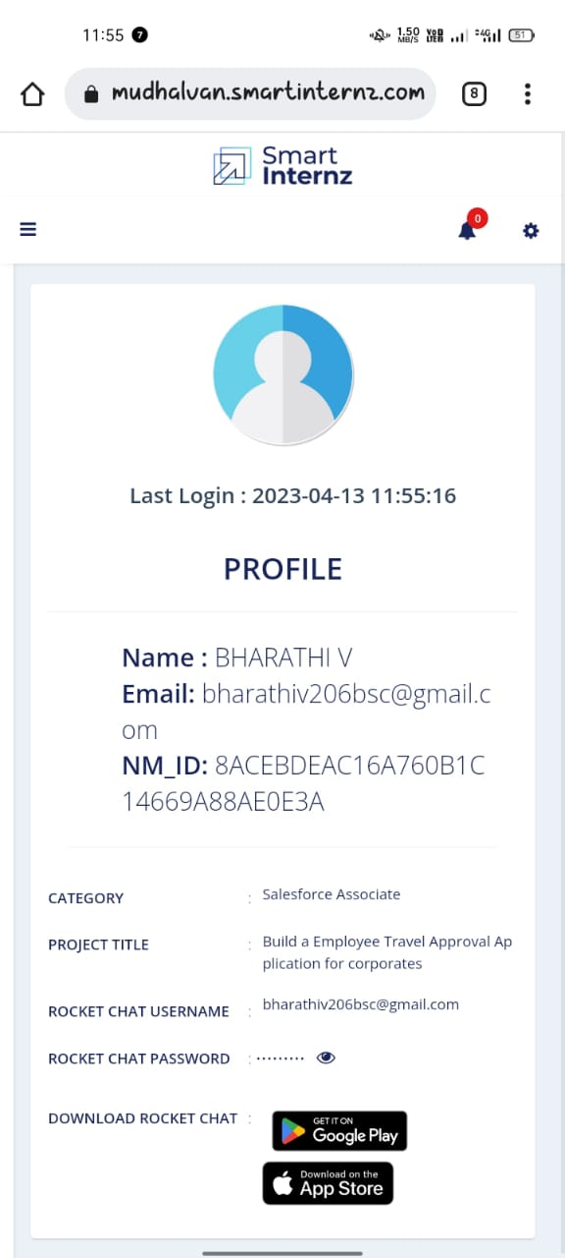

Team Member1 : BALAJI S

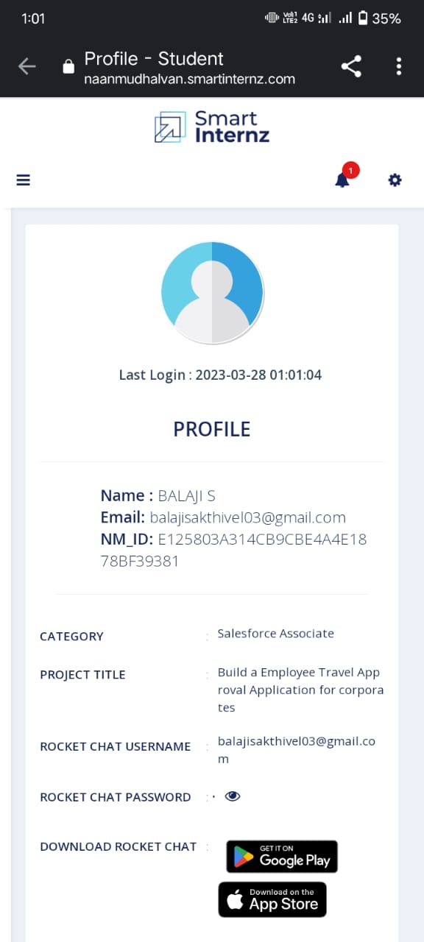

Team Member 2: BHARATHKUMAR P

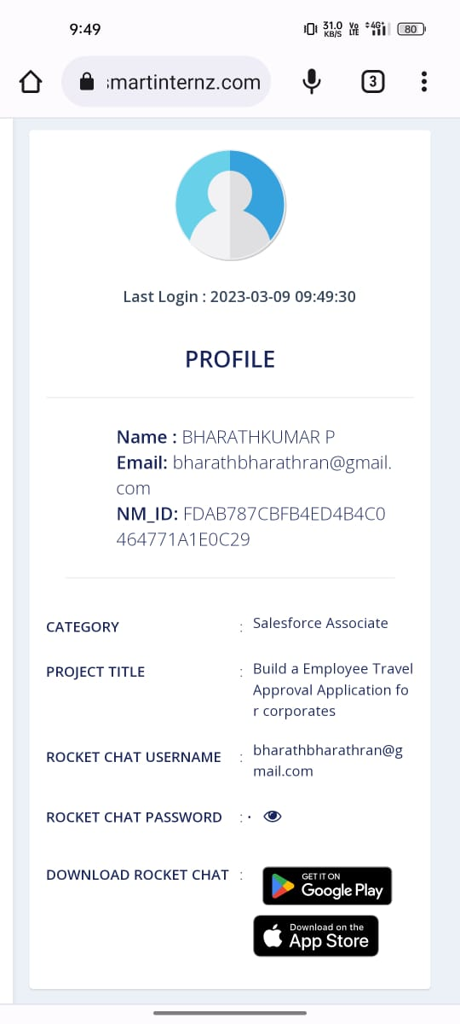

Team Member3 : DHEENADHAYALAN A

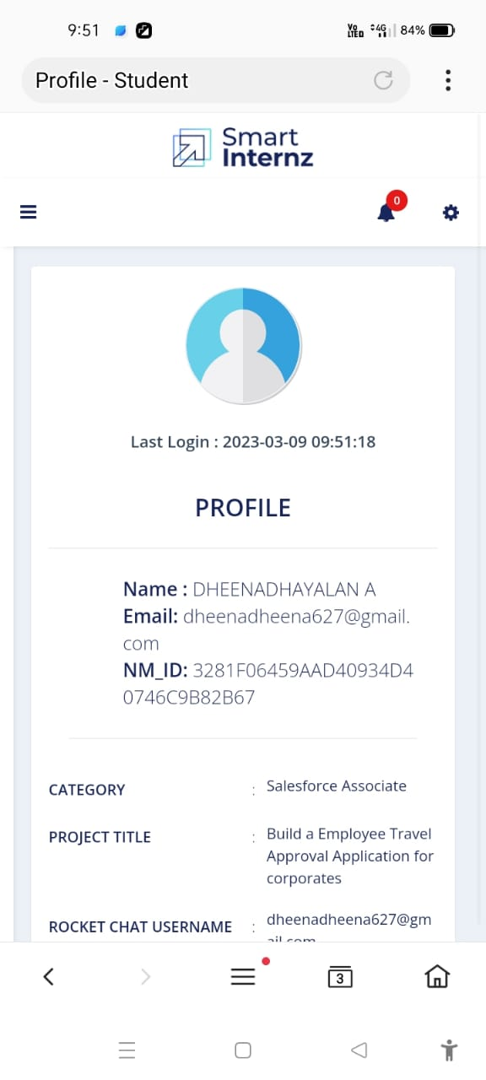

**Introduction**

Are you new to Salesforce? Not sure exactly what it is, or how to use it? Don’t know where you should start on your learning journey? If you’ve answered yes to any of these questions, then you’re in the right place. This module is for you. Welcome to Salesforce! Salesforce is game-changing technology, with a host of productivityboosting features, that will help you sell smarter and faster. As you work toward your badge for this module, we’ll take you through these features and answer the question, “What is Salesforce, anyway?”

Salesforce is your customer success platform, designed to help you sell, service, market, analyze, and connect with your customers. Salesforce has everything you need to run your business from anywhere. Using standard products and features, you can manage relationships with prospects and customers, collaborate and engage with employees and partners, and store your data securely in the cloud.

1.1. OVERVIEW

Naan Mudhalvan platform aims to provide dynamic information for college students on courses and relevant information about industry specific skill offerings. This will enable the student of Tamil Nadu to get training on their chosen field of interest that will help them in achieving their career goals.

Project Description

The project aim is to provide real-time knowledge for all the students who have basic knowledge of Salesforce and Looking for a real-time project. This project will also help to those professionals who are in cross-technology and wanted to switch to Salesforce with the help of this project they will gain knowledge and can include into their resume as well

1.2. PURPOSE

Learn

1. Real Time Salesforce Project

2. Object & Relationship in Salesforce

Travel approval means approval of official travel in advance buy an appropriately delegated officer, utillising the appropriate form or system. A travel request approvel process is a series of actions that an employee follows to acquire management consent to implement a trip.

This form ensures that travel within the company is feasible, authorized, organized, and properly managed.

If your employee are traveling for work frequently, then a business travel request form is very essential for your company. It gives you and finance managers an idea about the business trip and travel expenses.

Customization refers to custom software development and coding to add robust features to your CRM platform. These features can be integrated with your business to have a scalable impact.

2. Problem Definition & Design Thinking

2.1 EmpathyMap

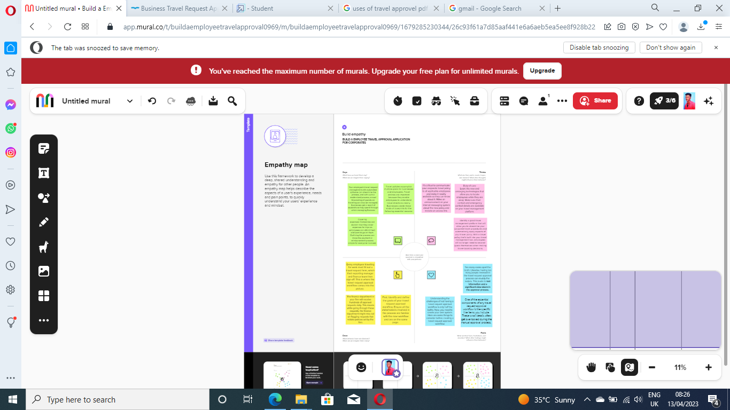

2.2 Ideation & Brainstorming Map

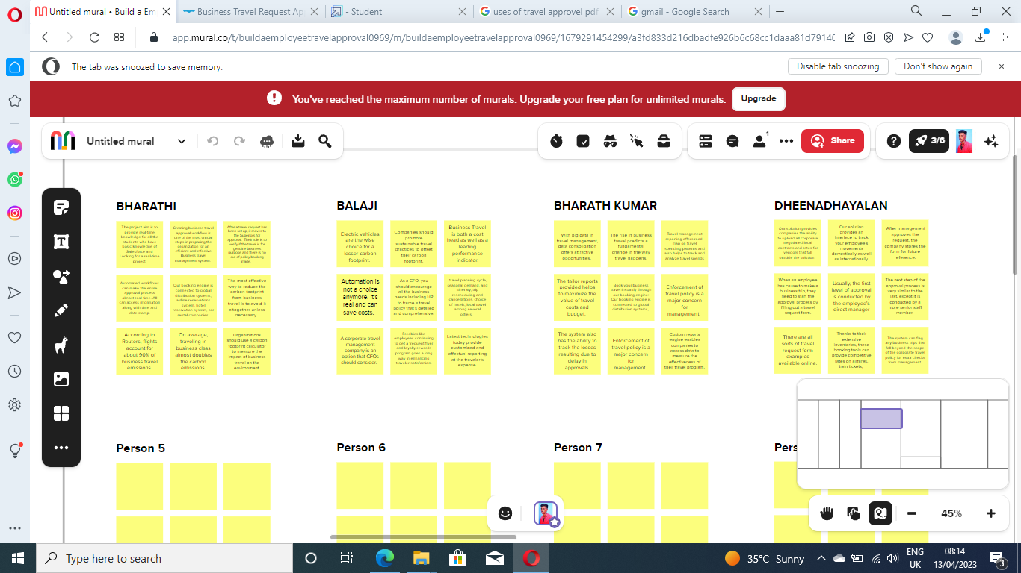

Result:

3.1 Data Model

Object Name Field in the object

Obj 1 Field label Data Type

Obj 2 Field label Data Type

3. Activity& screenshot

Milestone 1- Create Salesforce Org:

ACTIVITY -1:

Creating Developer Account Creating a developer org in salesforce. 1. Go to developers.salesforce.com/ 2. Click on sign up. 3. On the sign-up form, enter the following details: 1. First name & Last name 2. Email 3. Role: Developer 4. Company: College Name 5. County: India 6. Postal Code: pin code 7. Username: should be a combination of your name and company This need not be an actual email id, you can give anything in the format: [username@organization.com](mailto:username@organization.com)

**Click on sign up after filling these**.

**Creating Developer Account**

Creating a developer org in salesforce.

1. Go to <https://developer.salesforce.com/>

2. Click on sign up.

**3. On the sign up form, enter the following details :**

1. First name & Last name

2. Email

3. Role : Developer

4. Company : College Name

5. County : India

6. Postal Code : pin code

7. Username : should be a combination of your name and company This need not be an actual email id, you can give anything in the format : [username@organization.com](mailto:username@organization.com)

Click on sign up after filling these.

ACTIVITY-3:

Account Activation Go to the inbox of the email that you used while signing up. Click on the verify account to activate your account. The email may take 5-10mins, as

**Login To Your Salesforce Account**

1.Go to salesforce.com and click on login.

2.Enter the username and password that you just created.

3.After login the home page which you will see.

Salesforce Login : <https://login.salesforce.com/>

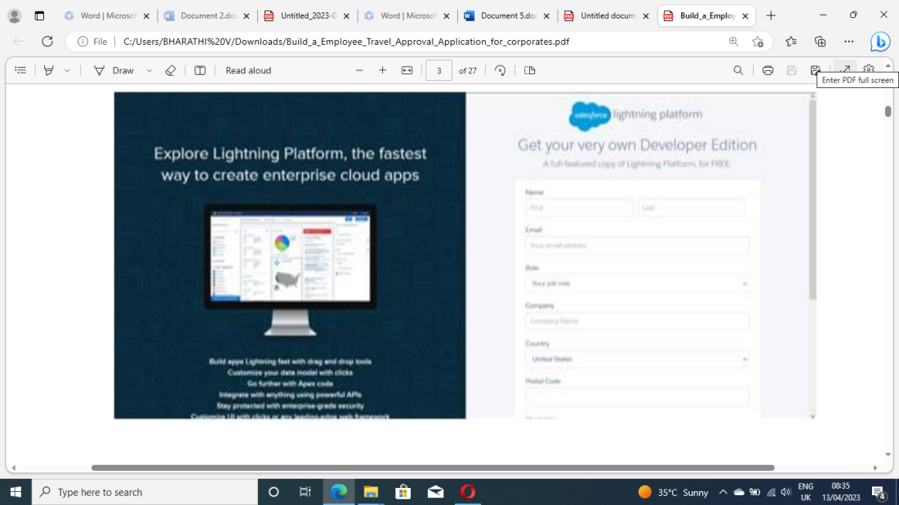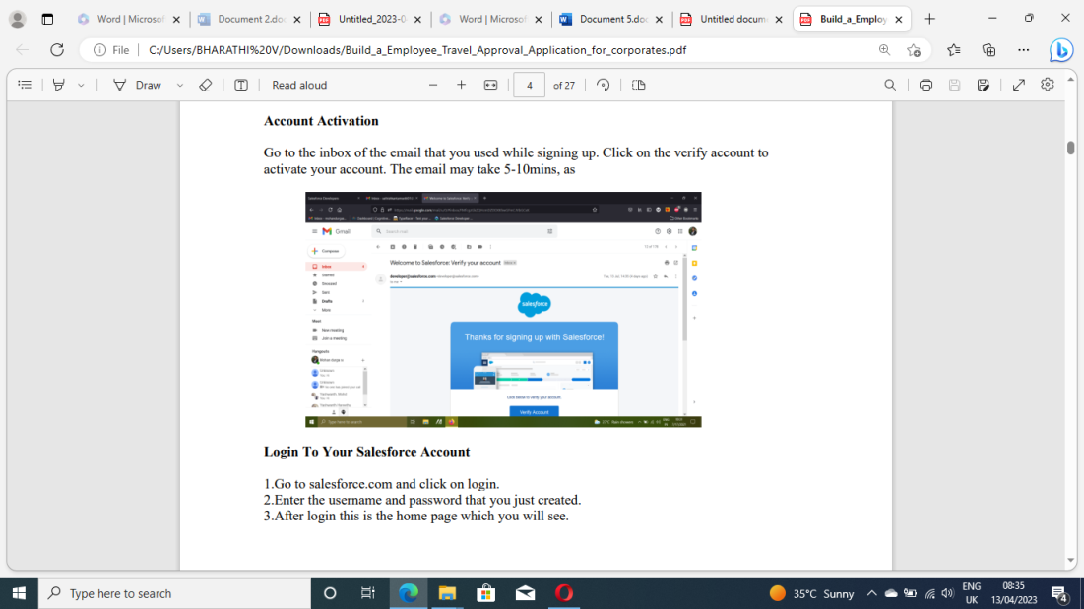

**Milestone 2**

Creating the Application:

The AppManager is your go to place for managing apps for lightning experience. It shows all your connected apps and salesforce apps. Use the lightning experience app manager to view all your salesforce apps.

Activity-1:

Create the Travel Application

Search AppManager in quick find box, click on new lightning app. Before creating the application download this zip file and extract

it.https://developer.salesforce.com/files/TravelAppWorkshopFiles.zip

Steps • From Setup, enter App Manager in the Quick Find and select App Manager

• Click New Lightning App. Enter Travel Approval as the App Name, then click Next

● Under App Options, leave the default selections and click Next.

● Under Utility Items, leave as is and click Next

● From Available Items, select Department, Travel Approval, Expense Item, Reports, andDashboards and move them to Selected Items. Click Next.

● From Available Profiles, select System Administrator and move it to Selected Profiles.Click Save & Finish.

● To verify your changes, click the App Launcher, type Travel Approval and select the Travel Application app.

Creating The Application

The AppManager is your go to place for managing apps for lightning experience. It shows all your connected apps and salesforce apps. Use the lightning experience app manager to view all your salesforce apps.

<https://www.youtube.com/watch?v=GR61sx2Kdis&feature=youtu.be>

**Create The Travel Application**

Search AppManager in quick find box, click on new lightning app. Before creating the application download this zip file and extract it.

<https://developer.salesforce.com/files/TravelAppWorkshopFiles.zip>

Steps

1. From Setup, enter App Manager in the Quick Find and select App Manager.

2. Click New Lightning App. Enter Travel Approval as the App Name, then click Next

3. Under App Options, leave the default selections and click Next.

4. Under Utility Items, leave as is and click Next.

5. From Available Items, select Department, Travel Approval, Expense Item, Reports, and Dashboards and move them to Selected Items. Click Next.

6. From Available Profiles, select System Administrator and move it to Selected Profiles. Click Save & Finish.

7. To verify your changes, click the App Launcher, type Travel Approval and select the Travel Application app.

**An Object**

Salesforce objects are database tables that permit you to store data that is specific to an organization. It consists of fields (columns) and records (rows).

**Salesforce objects are of two types:**

1. Standard Objects: Standard objects are the kind of objects that are provided by salesforce.com such as users, contracts, reports, dashboards, etc.

2. Custom Objects: Custom objects are those objects that are created by users. They supply information that is unique and essential to their organization. They are the heart of any application and provide a structure for sharing data.

In this Travel Approval application we will be creating 3 objects: Department

Travel approval and

Expense Item

**Custom Object Creation**

1. After you Login to your org, click create on the right side of the page and select custom object.

**To create an object:**

From the setup page then Click on Object Manager then Click on Create then Click on Custom Object.

**On Custom object defining page:**

Enter the label name, plural label name, click on Allow reports, Allow search then Save.

**Create 3 Custom Objects And Tabs**

**Create 3 custom objects and tabs**

a) Department

b) Travel Approval

c) Expense Item

**Create Department Object**

1.From Setup, click Object Manager.

2.Click Create, then select Custom Object.

3.Give the name as Department

To Navigate to Setup page:

Click on gear icon then click setup.

**To create an object:**

From the setup page then Click on Object Manager then Click on Create then Click on Custom Object.

**On Custom object defining page:**

Enter the label name, plural label name, click on Allow reports, Allow search then Save.

4.Now the tabs section opens, add this tab to the travel app.

**Create Travel Approval Object**

1.Navigate back to Object Manager

2. Click Create then select Custom Object.

3.Enter these details

**Note- Please refer Pg No. 11**

https://smartinternz.s3.amazonaws.com/Build_a_Employee_Travel_Approval_Application_for_corporates. pdf

4.Allow Reports, search, and launch a new tab and add this tab to the travel app.

**A Tab**

Tabs in Salesforce help users view the information at a glance. It displays the data of objects and

other web content in the application.

**There are mainly 4 types of tabs:**

**Standard Object Tabs:**

Standard object tabs displays data related to standard objects.

**Custom Object Tabs:**

Custom object tabs displays data related to custom objects. These tabs look and function just like standard tabs.

**Web Tabs:**

Web Tabs display any external Web-based application or Web page in a Salesforce tab.

**Visualforce Tabs:**

Visualforce Tabs display data from a Visualforce Page.

**Create A Custom Tab**

Now create a custom tab. Click the Home tab, enter Tabs in Quick Find and select Tabs. Under Custom Object Tabs, click New.

1. For Object, select Event.

2. For Tab Style, select any icon.

3. Leave all defaults as is. Click Next, Next, and Save.

In the same way create other objects such as Attendees, Speaker and Vendor.

**Create - Fields& Relationships**

What are fields? Fields in Salesforce represents what the columns represent in relational databases.

It can store data values which are required for a particular object in a record. There are 2 types of

fields in salesforce:

**1.Standard fields:** There are four standard fields in every custom object that are Created By, Last Modified By, Owner, and the field created at the time of the creation of an object. These fields cannot be deleted or edited and they are always required. For standard objects, the fields which are present by default in them and cannot be deleted from standard objects are standard fields.

**2.Custom fields:** The Custom fields which are added by the administrator/developer to meet the business requirements of any organization. They may or may not be required.

**Create Fields & Relationships**

1. Click Fields & Relationships, and click New.

2. For data type, select Currency.

3. Enter these details.

a. For Field Label, enter Amount

b. For Length, enter 16

c. For Decimal places, enter 2

d. Select Required

4. Click Next, Next, then Save & New

**Create The Expense Type Field.**

1. Select Picklist as the data type.

2. Select Enter values, with each value separated by a new line.

3. Add these values:(Airfare, Hotel, RentalCars, Meals,Others)

4. Select Required.

5. Click Next, Next, then Save & New.

**Create The Travel Approval Field.**

Create the Travel Approval field

1. Select Master-Detail Relationship data type, click Next.

2. Select Travel Approval from the Related To menu.

3. Click Next four times, then click Save.

**Import Departments**

In order to complete this milestone, you need to download the reference file https://developer.salesforce.com/files/TravelAppWorkshopFiles.zip?_ga=2.108173638.59756 40 88.1674441525-733189446.1673935386

**Import Departments**

From Setup, click the Home tab.

1.In the Quick Find box, enter Data Import and select Data Import Wizard.

2. Click Launch Wizard! Click the Custom Objects tab and select the Departments object.

3. Next, select Add new records.

4. Drag and drop the Departments.csv file you downloaded using zip file or click the CSV icon and browse to select your file. Select Next.

5. Since the field names in the CSV file (CSV Header) are the same as the field names in your object (Mapped Salesforce Object), the fields are automatically mapped. Click Next.

6. The next screen gives you a summary of your data import. Click Start Import.

7. Click OK on the popup.

8. This takes you to the bulk import summary window that shows that the process has completed and 16 records have been successfully imported or processed. You’ll also get an email notification confirming the import.

**Customize User Interface**

In this Milestone we are going to setup the users, customizing the page layouts

**Create User And Setup Approvals**

1.Enter users in the quickfind box and select users.

2.Click new user.

3.Now give the name as you wish but the email must be real email address.

4.For username field follow the instructions a. Firstname.@.com b. ...or create a username of your choice that should be unique

5.Give the role as CEO, Profile as System Administrator and license as Salesforce.

6.From Setup, enter Users in the Quick Find box and select Users.

7.Select your user account in the list provided. (Click on your name in the All Users list.)

8.Click Edit.

9.Scroll down to Approver Settings. Set your manager as the user you have created recently.

10.Click Save.

**Use Customization**

Customization refers to custom software development and coding to add robust features to your CRM platform. These features can be integrated with your business to have a scalable impact.

**Customize Travel Approval Object Page Layout**

1.From the Object Manager, search for the travel approval object and click on page layouts and click edit.

2.Drag Section from the top pane to the lower pane directly below the Information section. When dragging over the page, you get a visual indicator of where you can drop the new section.

3.Name the section Trip Info, leave the rest of the settings at their default values, then click OK.

4. Drag the Purpose of Trip field from the Information section to the Trip Info section.

5.Drag Trip Start Date and Trip End Date from the top pane into the left-hand column of the Trip Info section.

6.Drag Out-of-State and Destination State from the top pane into the right-hand column of the Trip Info section.

7.Drag the Department field from the left-hand column of the Trip Info section to the right-hand column.

8.Click Save

Note: You may need to refresh your browser screen for the changes to show up.

Dashboards

**Add Business Logic To Travel App**

From this milestone we are going to create validation rules, rollup summary fields, formula fields, workflows and approval process.

**Create Validation Rule**

1.Search for the travel approval object from the object manager and open the object.

2.Click on validation rules and give your rule a name and make sure that the rule is set to active.

3.In the error condition formula enter Trip_End_Date__c < Trip_Start_Date__c.

4.For error location select field and pick trip end date as the location for error.

**Create RollUp Summary Fields**

Create RollUp Summary Fields

1. From the Travel Approval object, select Fields & Relationships.

2. Click New.

3. Select the Roll-Up Summary data type.

4. Click Next.

5. Enter the following values for the field details

a. Field Label: Total Expenses

b. Field Name: Total_Expenses (this automatically gets set when you tab out of the Field Label field

6. Click Next.

7. Configure the roll-up calculation.

a. Summarized Object: Expense Items

b. Roll-Up Type: SUM

c. Field to Aggregate: Amount

d. Filter Criteria: All records should be included in the calculation

8. Click Next, Next, Save

**Create Formula Fields**

1. First, we need to upload a zip file to your Salesforce environment that contains all the images we use. You should have a file titled StatusImages.zip.

2. Click the Home tab to navigate back to the main setup page.

3. Click Custom Code | Static Resources (or enter Static in the Quick Find to filter down the options).

4. Click New.

5. Enter the following values for your static resource

**Note - Please refer Pg no. - 22** https://smartinternz.s3.amazonaws.com/Build_a_Employee_Travel_Approval_Application _for_corporates.pdf

6. Now select the travel approval object.

7. Select Fields & Relationships.

8. Click New

9. Select Formula data type.

10. Click Next.

11. Enter the following values:

Field Label: Status Indicator

Field Name: Status_Indicator (This automatically gets sent when you tab out of the Field Label field) Formula Return Type: Text

12. Click Next.

13. Copy and paste the following formula into the formula editor.

IF( ISPICKVAL( Status__c , 'Approved'), IMAGE("/resource/StatusImages/thumbs-up.png", "Accepted", 20, 20),

IF ( ISPICKVAL( Status__c , 'Rejected'),

IMAGE("/resource/StatusImages/thumbs-down.png", "Rejected", 20, 20),IMAGE("/resource/StatusImages/draft.png", "In-Process", 20, 20)))

14.Click Next, Next, Save.

**Reports**

Reports in Salesforce is a list of records that meet a particular criterion which gives an answer to a particular question. These records are displayed as a table that can be filtered or grouped based on any field.

**There are 4 types of report formats in Salesforce:**

**1.Tabular Reports:**

This is the most basic report format. It just displays the row of records in a table with a grand total. While easy to set up they can’t be used to create groups of data or charts and also cannot be used in Dashboards. They are mainly used to generate a simple list or a list with a grand total.

**2. Summary Reports:** It is the most commonly used type of report. It allows grouping of rows of data, view subtotal, and create charts.

**3. Matrix Report**:

It is the most complex report format. Matrix report summarizes information in a grid format. It allows records to be grouped by both columns and rows. It can also be used to generate dashboards. Charts can be added to this type of report.

**4. Joined Reports:**

These types of reports let us create different views of data from multiple report types. The data is joined reports are organized in blocks. Each block acts as a subreport with its own fields, columns, sorting, and filtering. They are used to group and show data from multiple report types in different views.

**Report types:**

Report type determines which set of records will be available in a report. Every report is based on a particular report type. The report type is selected first when we create a report. Every report type has a primary object and one or more related objects. All these objects must be linked together either directly or indirectly.

a. A report type cannot include more than 4 objects.

b. Once a report is created its report type cannot be changed.

**There are 2 types of report types:**

**1.Standard Report Types:**

Standard Report Types are automatically included with standard objects and also with custom objects where “Allow Reports” is checked. Standard report types cannot be customized and automatically include standard and custom fields for each object within the report type. Standard report types get created when an object is created, also when a relationship is created.

**Note:** Standard report types always have inner joins.

**2.Custom Report Types:**

Custom report types are reporting templates created to streamline the reporting process. Custom Reports are created by an administrator or User with “Manage Custom Report Types” permission. Custom report types are created when standard report types cannot specify which records will be available on reports.

In custom report types we can specify objects which will be available in a particular report. The primary object must have a relationship with other objects present in a report type either directly or indirectly.

**There are 3 types of access levels of folders:**

**1.Viewer:**

With this access level, users can see the data in a report but cannot make any changes except cloning it into a new report.

**2. Editor:** With this access level, users can view and modify the reports it contains and can also move them to/from any other folders they have access level as Editor or Manager.

**3. Manager:** With this access level, users can do everything Viewers & Editors can do, plus they can also control other user’s access levels to this folder. Also, users with Manager Access levels can delete the report.

From this milestone we are going to import the data and create the reports and dashboards for data

visualization in the application

**Add Report**

To create a report:

Go to the app then click on the reports tab

Click New Report

Select report type from category or from report type panel or from search panel ? click on start report.

Customize your report, then save or run it.

**Dashboards**

Dashboards let you curate data from reports using charts, tables, and metrics. If your colleagues need more information, then they're able to view your dashboard's data-supplying reports. Dashboard filters make it easy for users to apply different data perspectives to a single dashboard.

**Create Travel Approvals Dashboard**

1.Click on Dashboards tab from the travel approval application,click on new dashboard

2.Give your dashboard a name and click on +component , select the report which you created.

3.For the data visualization select any of the chart, table etc as your wish.

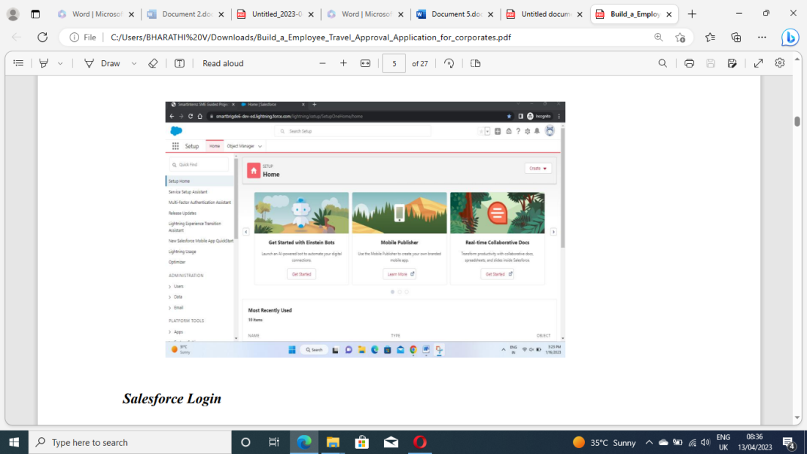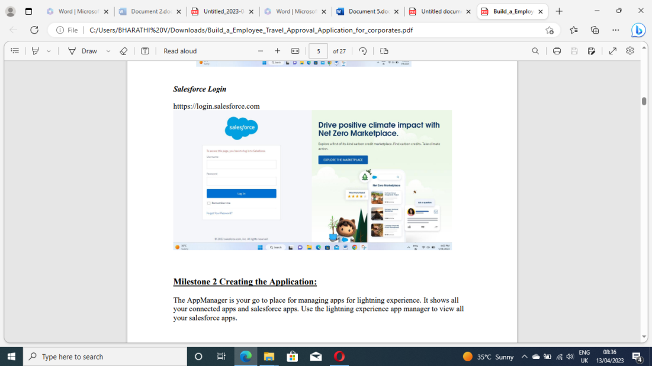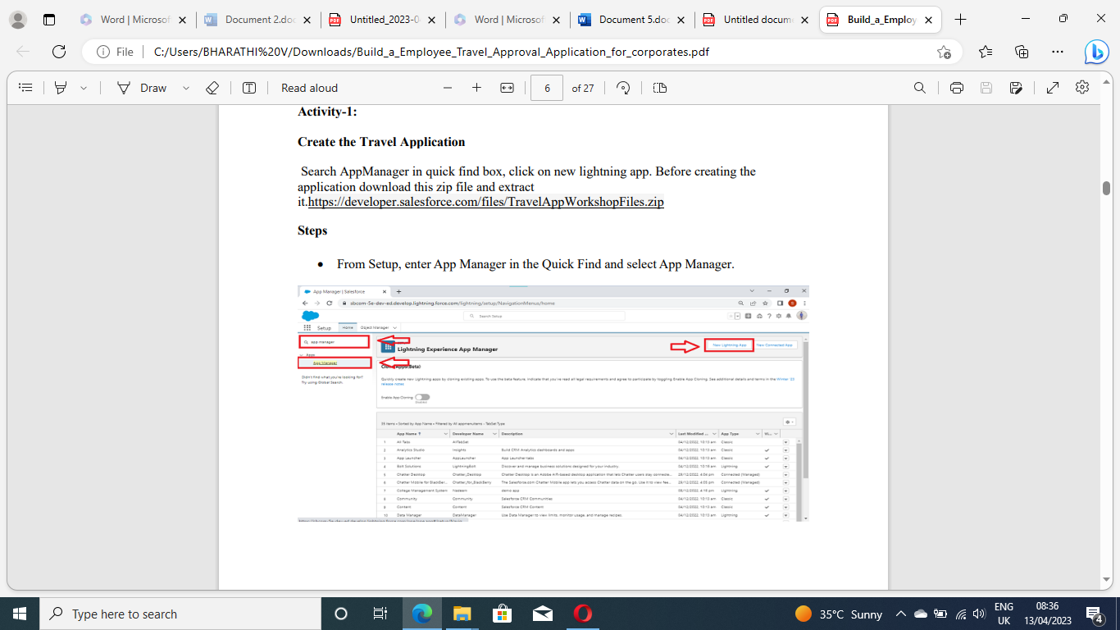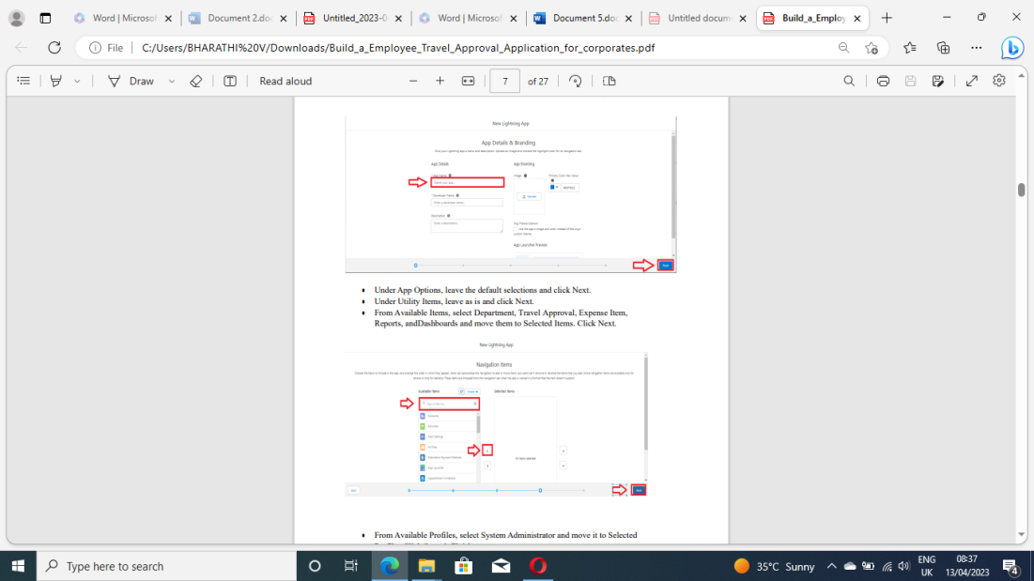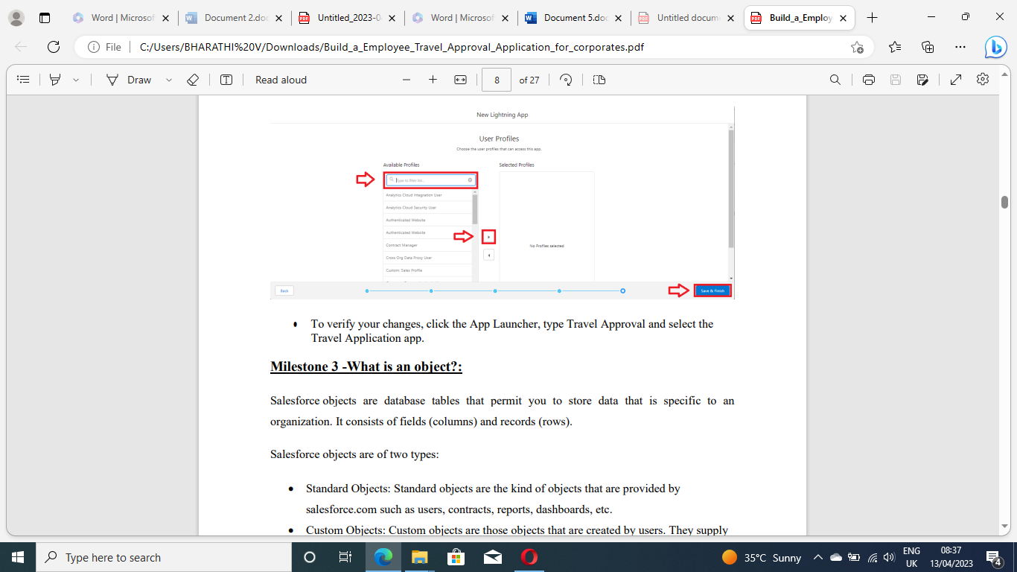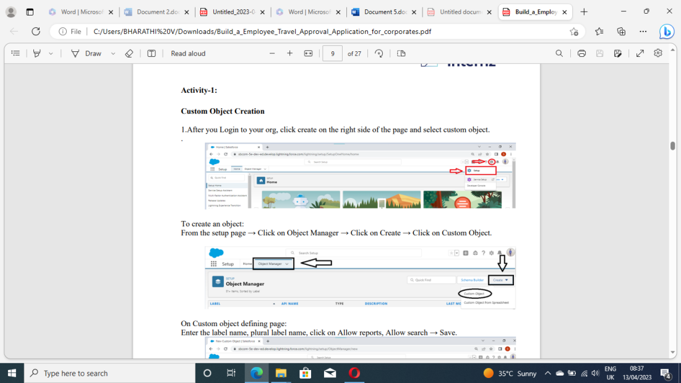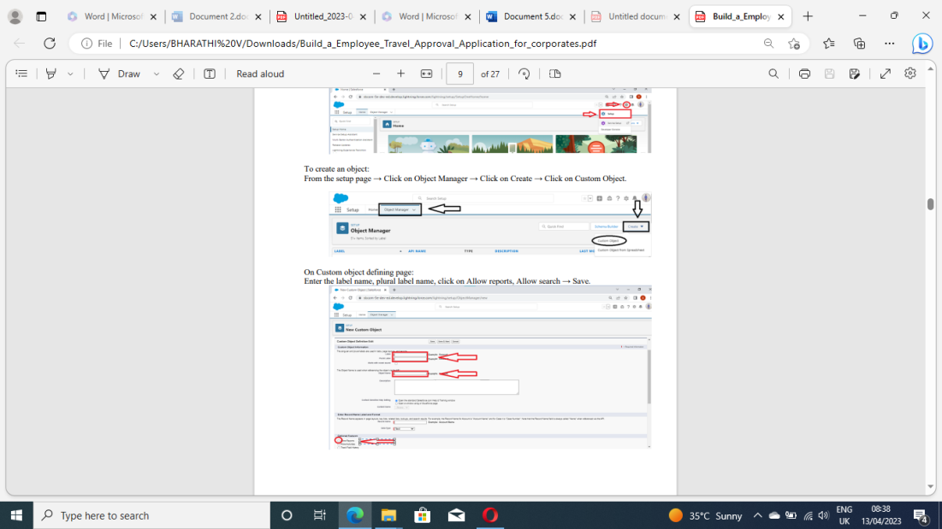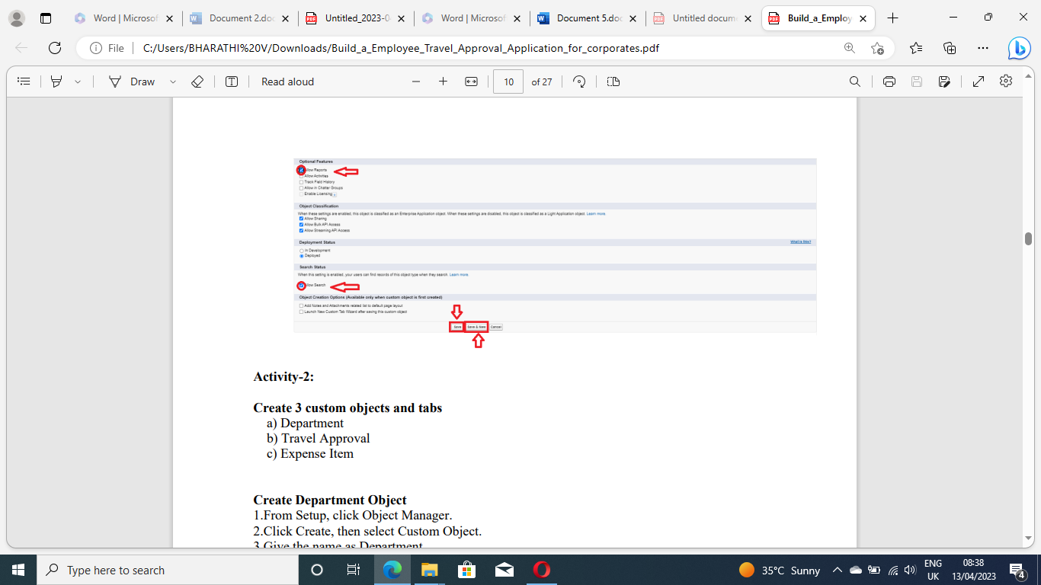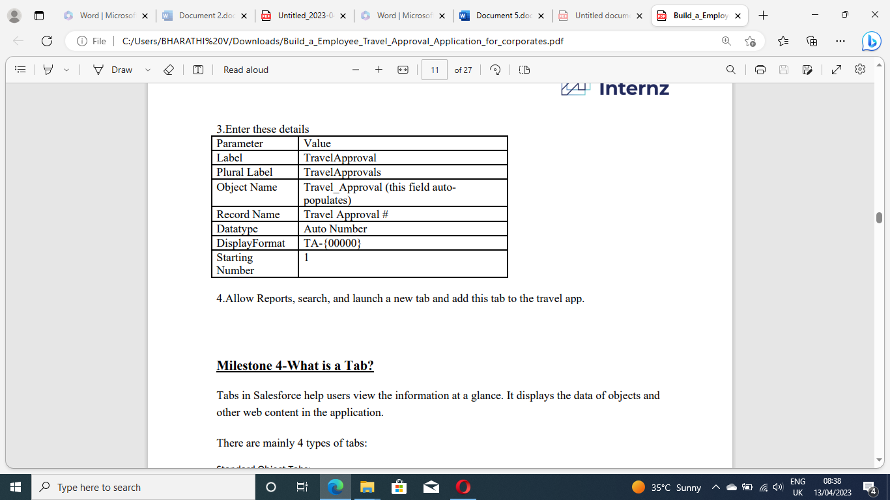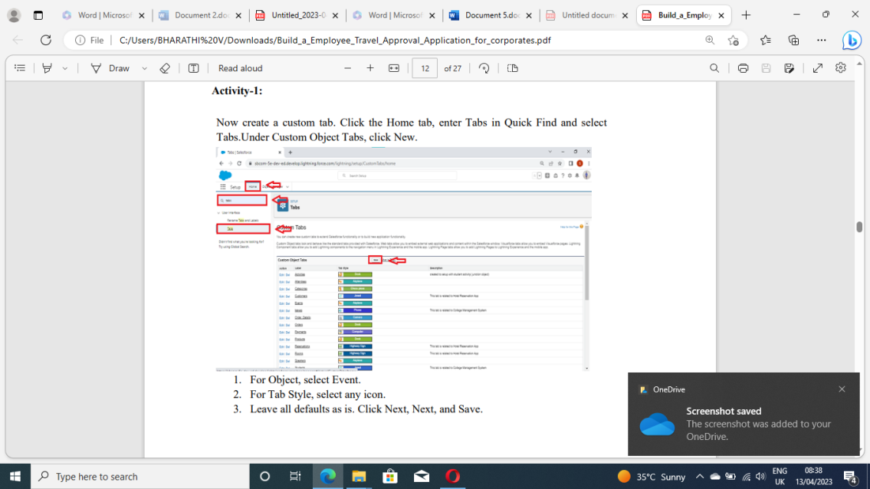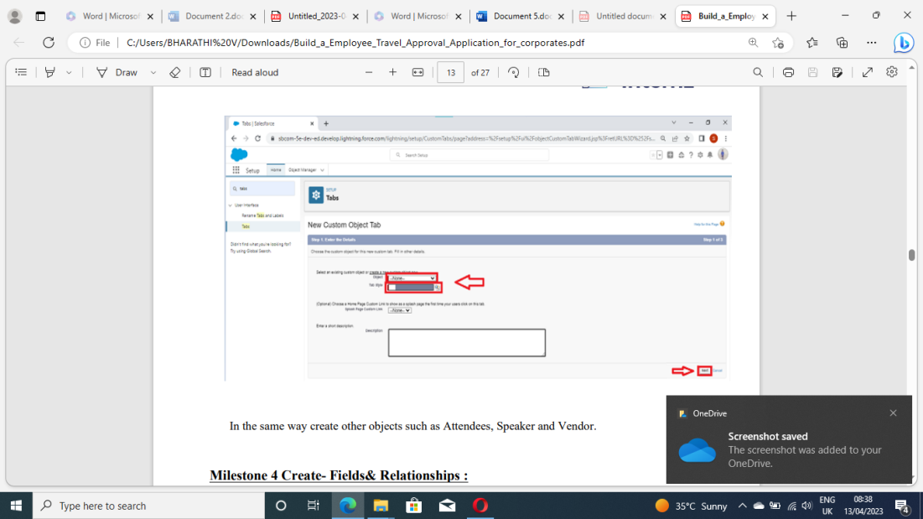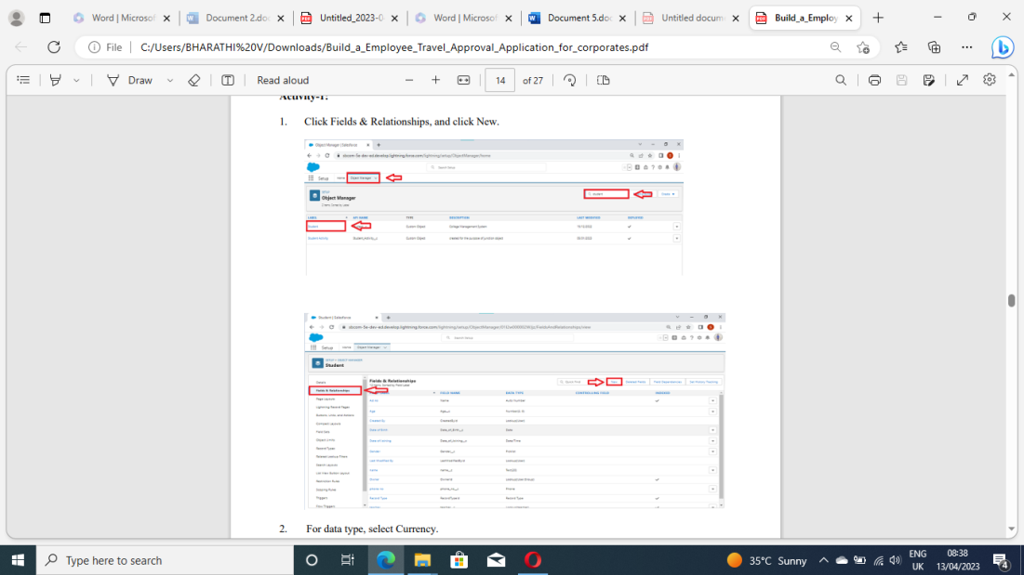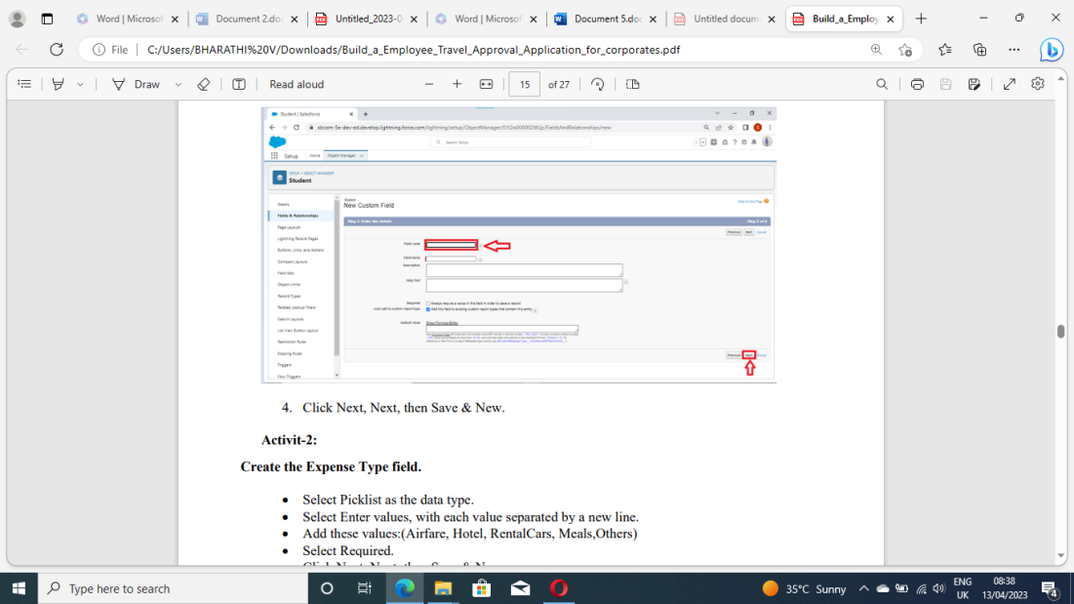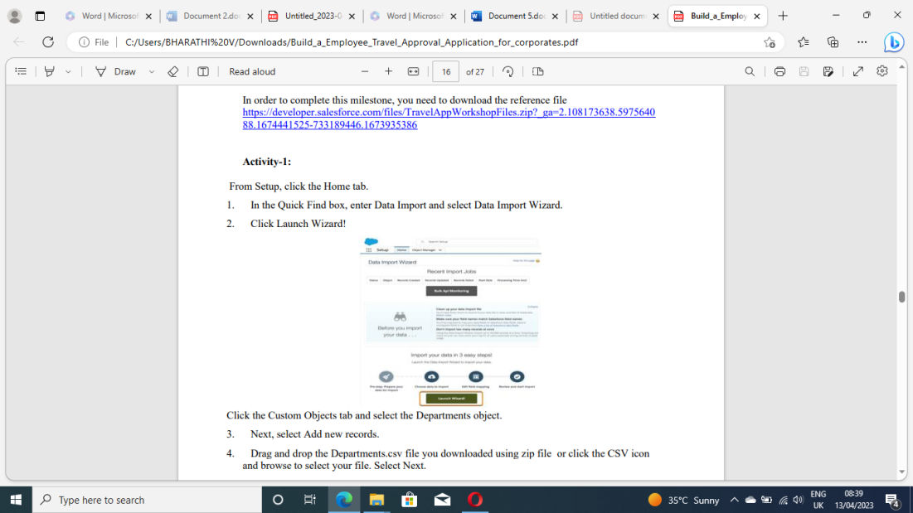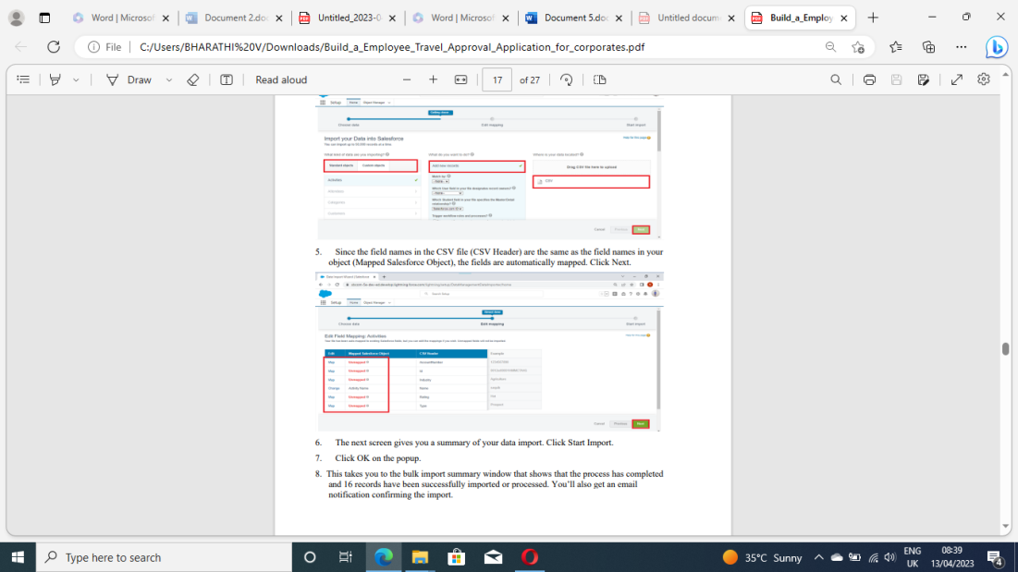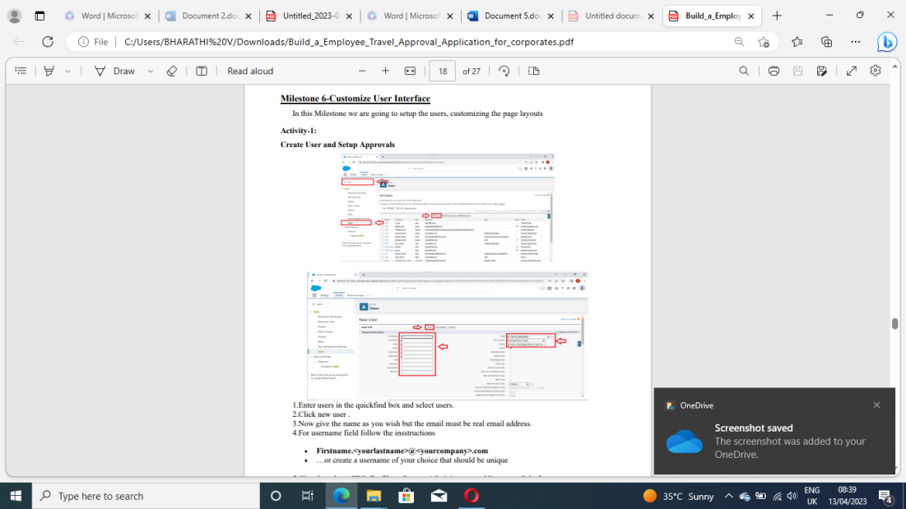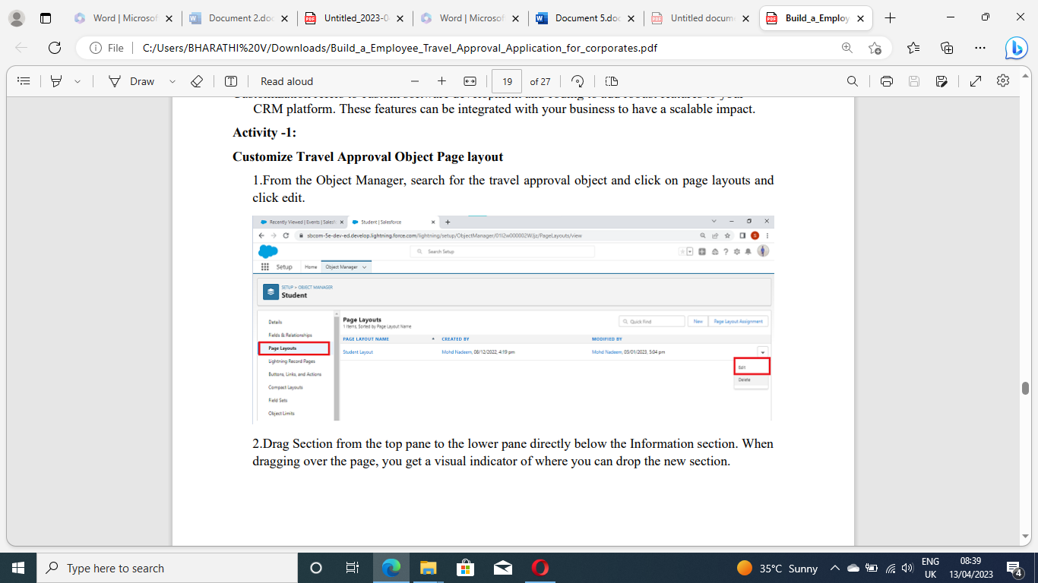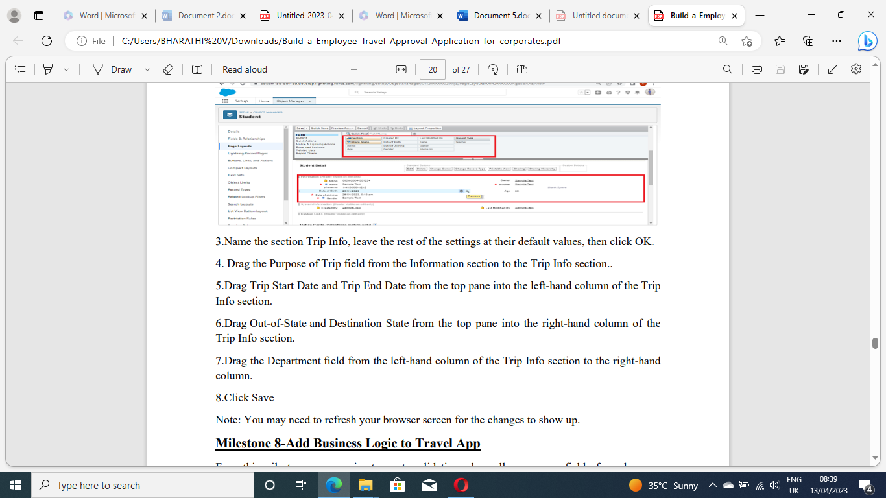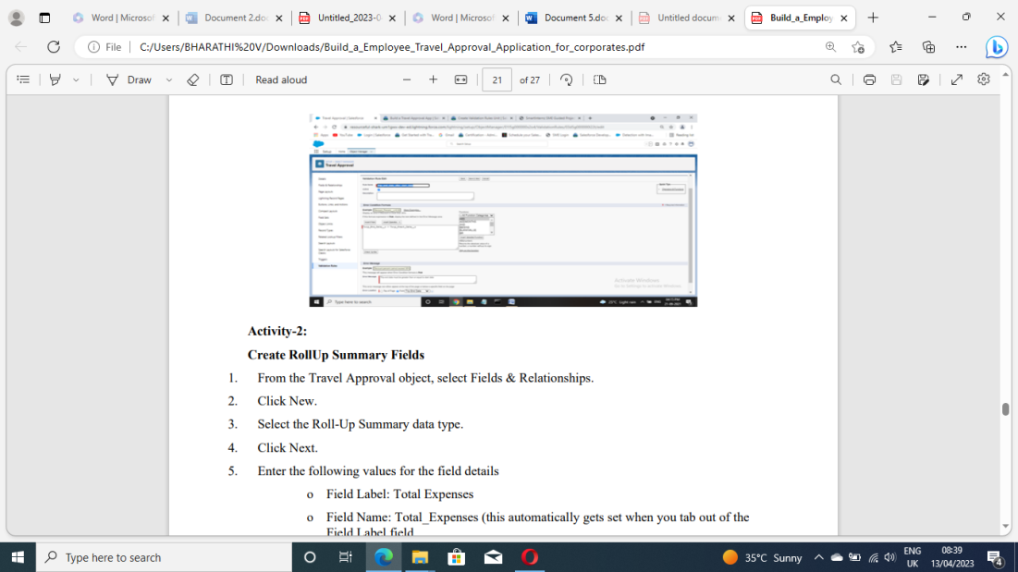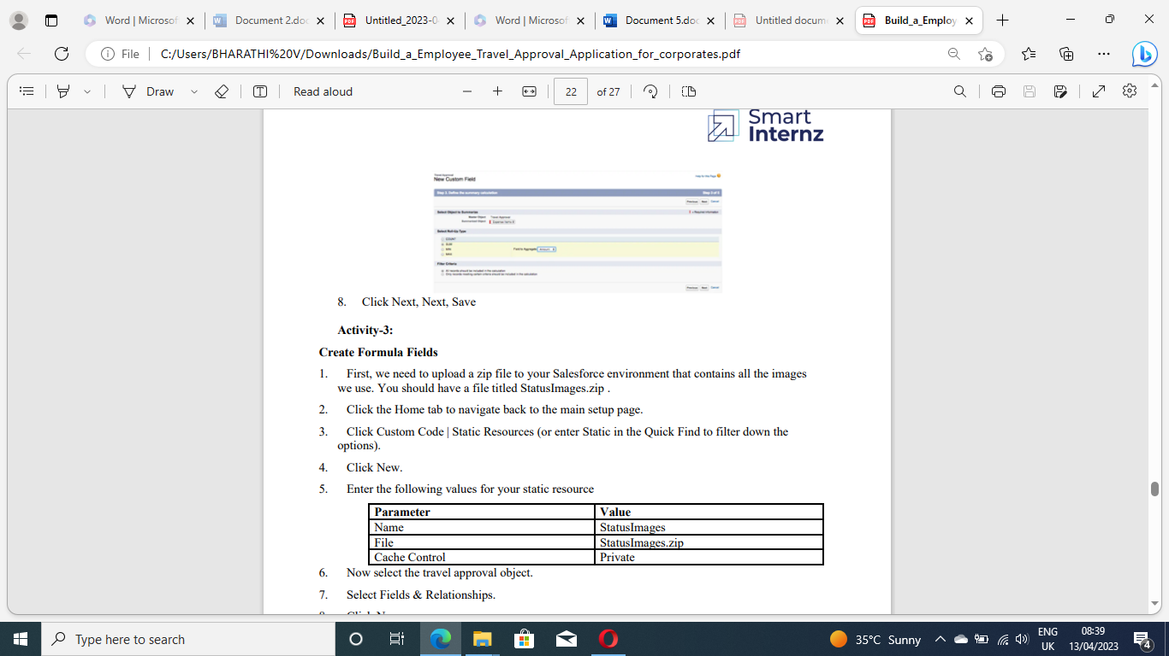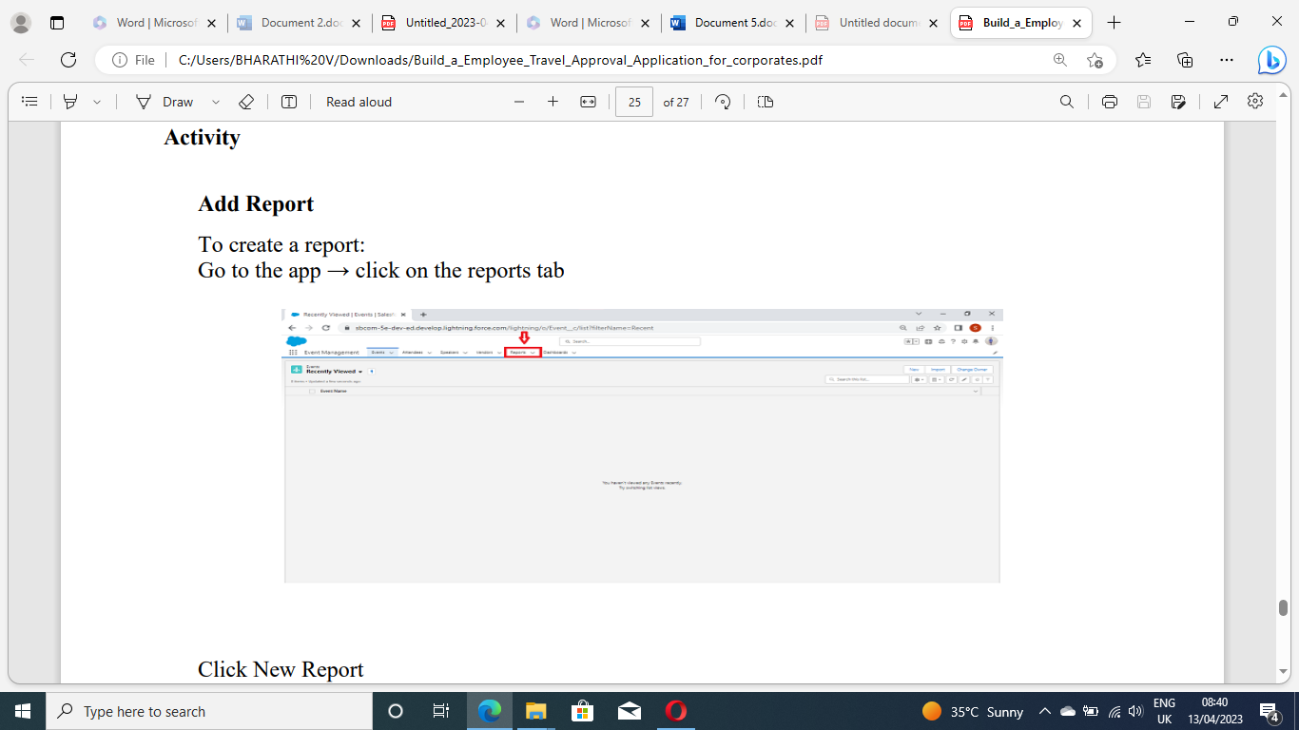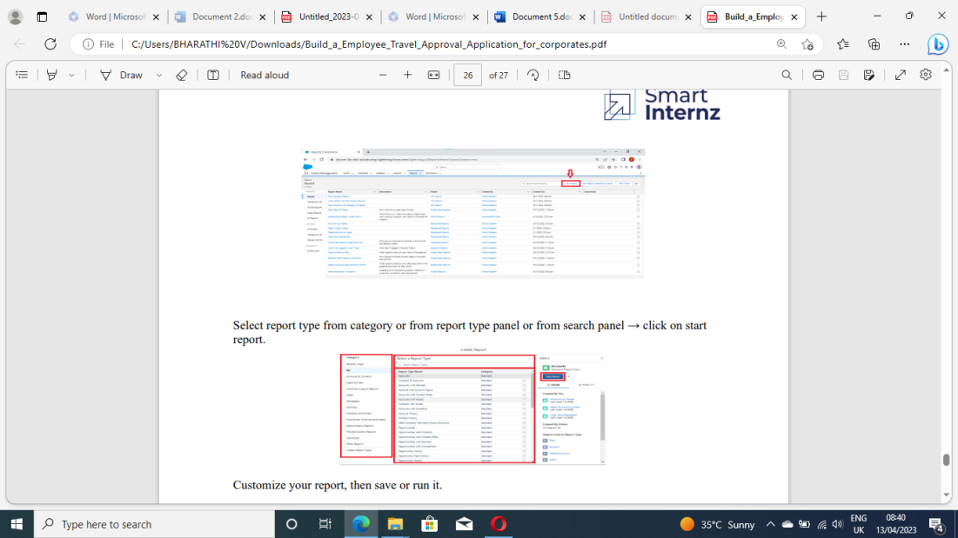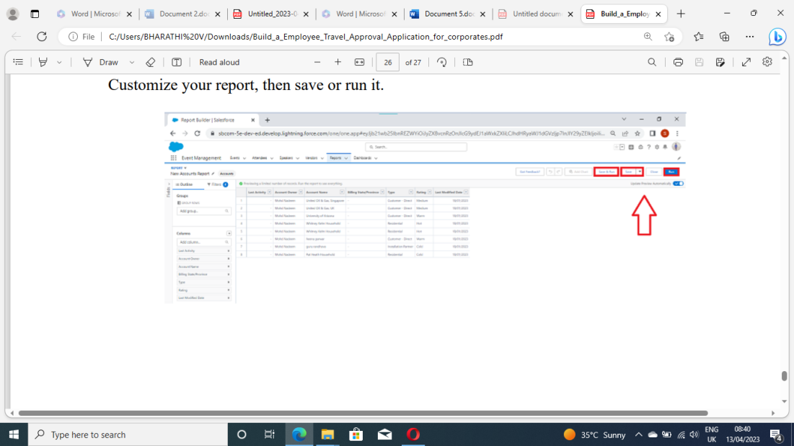

**4. Trailhead profile public URL**

Team Leader-- <https://trailblazer.me/id/bharv98>

Team Member 1 – <https://trailblazer.me/id/bbalaji58>

Team Member 2 – <https://trailblazer.me/id/bharp80>

Team Member 3 – <https://trailblazer.me/id/ddheena1>

**5. ADVANTAGES & DISADVANTAGES**

**ADVANTAGES:**

● Approvals on time. The entire process of planning and managing a trip is a long and stressful process.

● Customize approval workflows. The approval process can differ from company to company. ...

● Increase compliance and reduce costs. ...

● Faster process.

● Purpose of the travel

● Destination

● Duration of the stay

● Total expenditure involved in the trip

● Mention other details in the comments, such as expenses incurred by a team member who joined you on the trip

**Features of travel approval request**

**If the following conditions are met, the travel request will be automatically approved:**

■ If the requester specifies the estimated travel cost

■ The estimated travel cost is less than the maximum travel cost allowed

■ Travel advance requested by the requester is less than a predefined value

The travel request approval form will be sent to the manager or department head for approval, even if any one of the conditions mentioned above is not met.

After the approval, the request is sent to the finance team and the admin team for travel arrangements and advance.

**Approvals on time**

The entire process of planning and managing a trip is a long and stressful process. This means your employees need to spend hours looking for travel options, By automating the approval workflow, you can simplify the process. Your employees no longer have to run behind a manager or finance team for approvers.

**Customize approval workflows**

The approval process can differ from company to company. Using expense management software, you can customize the workflow based on your organization. You can set up multiple workflows within your organization, that will allow you to better manage your expense approval requests.

**Increase compliance and reduce costs**

A well-defined expense approval workflow will help in reducing non-policy-compliant expenses in your firm. You can now prevent expense frauds such as duplicate bills, overstated expenses, non-policy complaint items, manipulated invoices, etc.

**Faster process**

Most expense management software comes with mobile capabilities. This means approvers get notified of the travel requests sent by employees, which they can approve or reject fast. This reduces approval time and enhances the expense management process in your firm.

**DISADVANTAGES:**

This is the principal disadvantage of business travel, and frequent traveling can be responsible for creating significant health problems for employees. Because Of this, employees can't concentrate on their work, which affects the organization's productivity.

**6. APPLICATIONS**

The Travel Support System (this is the name that you can see on the screen when executing the application) is a small sample application for NaturalONE. As a sample application, its focus is to show NaturalONE functionality rather than being a full-fledged travel support application.

The Travel Support System (TSS) allows you to request and approve business trips. Flights, hotels and even more external information such as cell phone expenses or car rentals can be entered with the trip request. For the destination, weather information can be queried. A manager can do both, request own trips as well as approve trips that have been requested by employees. After the manager has approved single or multiple requests, the manager can print an itinerary or receive

Project Report Template

**7. CONCLUSION**

Business travelers are the face of the organization. They make awesome presentations, close deals, and keep the cash flowing. But you’ve got to spend money on travel to see the returns. Businesses continue to spend boatloads of money on corporate travel management to keep up these massive revenue streams.

The Travel Support System (TSS) allows you to request and approve business trips. Flights, hotels and even more external information such as cell phone expenses or car rentals can be entered with the trip request. For the destination, weather information can be queried. A manager can do both, request own trips as well as approve trips that have been requested by employees. After the manager has approved single or multiple requests, the manager can print an itinerary or receive the itinerary as a PDF file.

**8. FUTURE SCOP**

We have grown accustomed to remote working and video conferencing. Many business travelers are now rightly asking themselves whether they need to be in person at every meeting they might have attended in the past. Yet, our people want to remain connected with the people they work with and continue building significant relationships.

The reality is the pandemic has changed travelers’ values. Accenture’s Life Reimagined research, which surveyed 25,000 consumers globally, finds that there are five new factors driving buying habits, that I have seen echo amongst our own people at Accenture

1. Health and safety

2. Service and personal care

3. Ease and convenience

4. Product origin

5. Trust and reputation.